Nama : Tubagus Ganendra Krisna Priya

NIM : 2239099057

Mata Kuliah : PKPL B (Skenario Uji Manual PL-pert6)

**Manual Testing Scenario Software Restoku - Kasir Warung Makan**

|  |  |
| --- | --- |
| Project Name : Restoku – Kasir Warung Makan | Reviewed By : Tubagus Ganendra |
| Module Name : User | Reviewed Date :04/11/2022 |
| Author : PT. Restoku Andalan Indonesia | |

|  |  |  |  |
| --- | --- | --- | --- |
| Scenario ID | Module | Requirement | Test Scenario |
| TS01 | User | R1 Restoku Halaman Login | Check Launching Application |
| TS02 | User | R1 Restoku Halaman Login | Check Capture Form |
| TS03 | User | R1 Restoku Halaman Login | Check User Login |
| TS04 | User | R2 Restoku Halaman Utama User | Check Navigasi menu dan home page |
| TS05 | User | R3 Insert | Check Menambah Menu |
| TS06 | User | R3 Delete | Check Menghapus Menu |

**Manual Testing**

TS01 = Check Launching Aplikasi

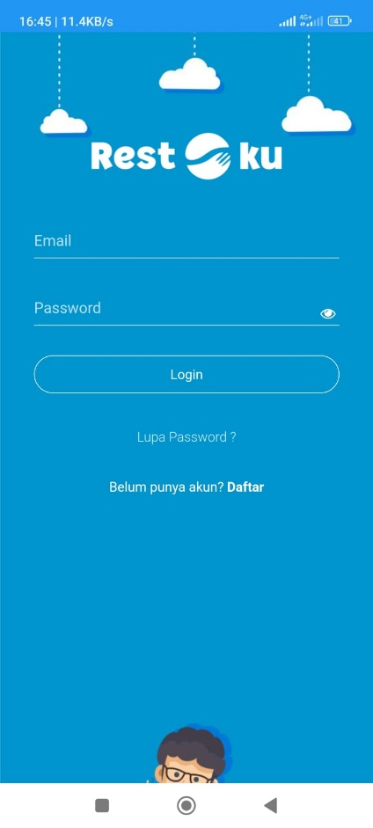

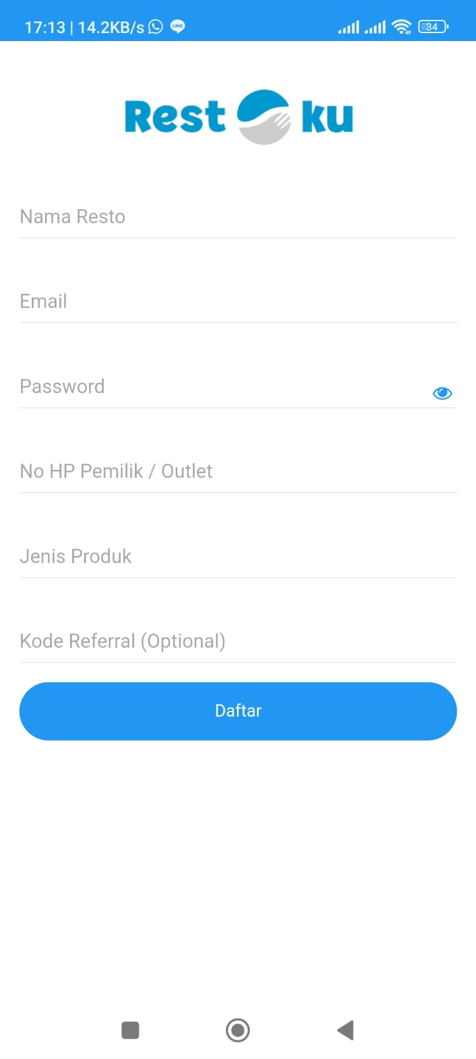TS02 = Check Capture Form

|  |  |  |  |  |  |  |  |  |  |  |  |  |
| --- | --- | --- | --- | --- | --- | --- | --- | --- | --- | --- | --- | --- |
| Inputs | C1 | C2 | C3 | C4 | C5 | C6 | C7 | C8 | C9 | C10 | C11 | C12 |
| Nama Resto | Yes | Yes | Yes | Yes | Yes | Yes | No | No | No | No | No | No |
| Email | Yes | No | Yes | Yes | Yes | Yes | Yes | No | No | No | No | No |
| Password | Yes | Yes | No | Yes | Yes | Yes | Yes | Yes | No | No | No | No |
| No HP | Yes | Yes | Yes | No | Yes | Yes | Yes | Yes | Yes | No | No | No |
| Jenis Produk | Yes | Yes | Yes | Yes | No | Yes | Yes | Yes | Yes | Yes | No | No |
| Kode Referral | Yes | Yes | Yes | Yes | Yes | No | Yes | Yes | Yes | Yes | Yes | No |
| Result |  | Error | Error | Error | Error |  | Error | Erorr | Error | Error | Error | Error |

|  |  |  |  |  |  |  |
| --- | --- | --- | --- | --- | --- | --- |
| Inputs | C1 | C2 | C3 | C4 | C5 | C6 |
| Email | Yes | Yes | Yes | No | Yes | No |
| Password | Yes | No | Yes | Yes | No | No |
| Login | Yes | Yes | No | Yes | No | No |
| Result |  | Error | Error | Error | Error | Error |

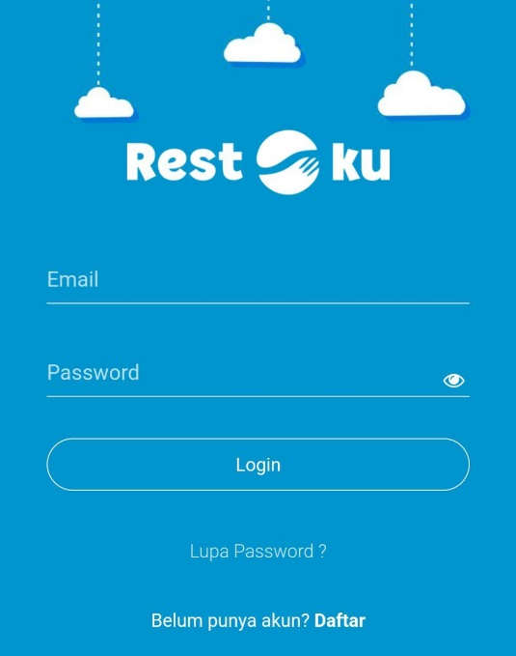TS03 = Check User Login

TS04 = Check Navigasi menu dan home page

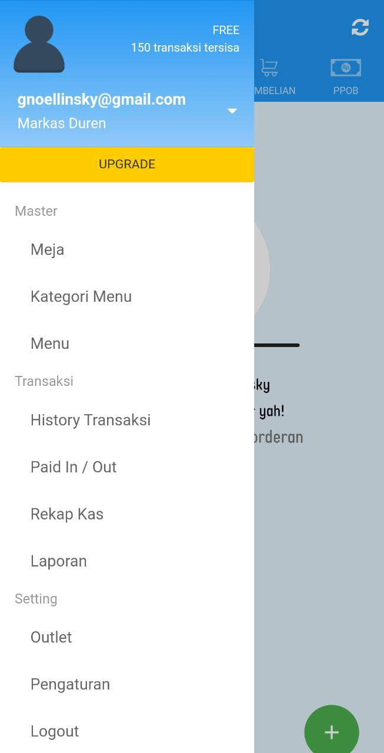

TS05 = Check Insert Menu

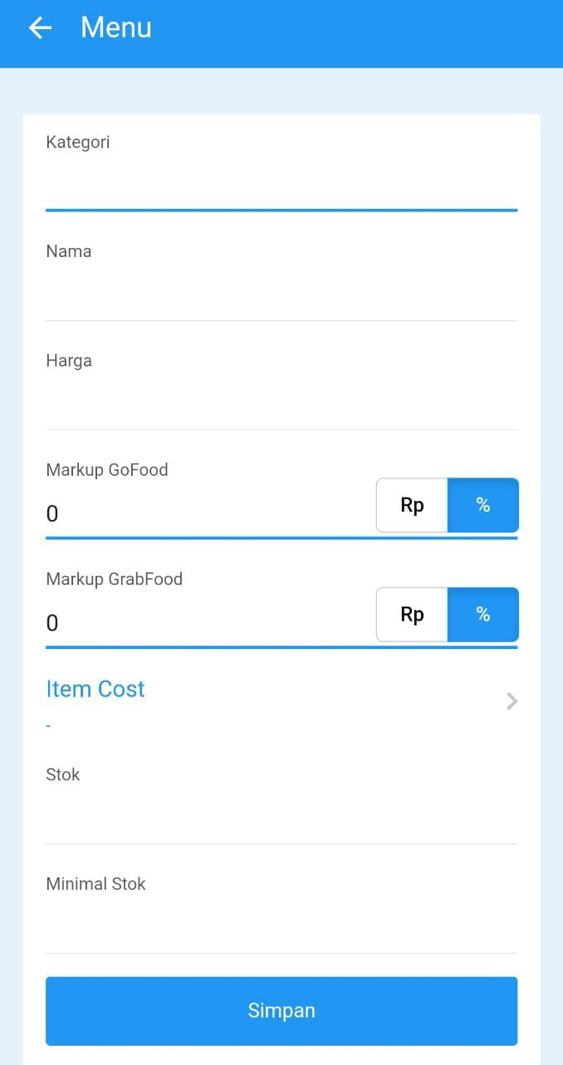

|  |  |  |  |  |  |  |  |  |  |  |
| --- | --- | --- | --- | --- | --- | --- | --- | --- | --- | --- |
| Inputs | C1 | C2 | C3 | C4 | C5 | C6 | C7 | C8 | C9 | C10 |
| Kategori | Yes | Yes | Yes | Yes | Yes | Yes | Yes | Yes | No | No |
| Nama | Yes | No | Yes | Yes | Yes | Yes | Yes | Yes | No | No |
| Harga | Yes | Yes | No | Yes | Yes | Yes | Yes | Yes | No | No |
| Markup Gofood | Yes | Yes | Yes | No | Yes | Yes | Yes | No | Yes | No |
| Markup Grabfood | Yes | Yes | Yes | Yes | No | Yes | Yes | No | Yes | No |
| Stock | Yes | Yes | Yes | Yes | Yes | No | Yes | Yes | No | No |
| Minimal Stock | Yes | Yes | Yes | Yes | Yes | Yes | No | Yes | No | No |
| Results |  | Error | Error |  |  | Error | Error |  | Error | Error |

TS06 = Check Delete Menu

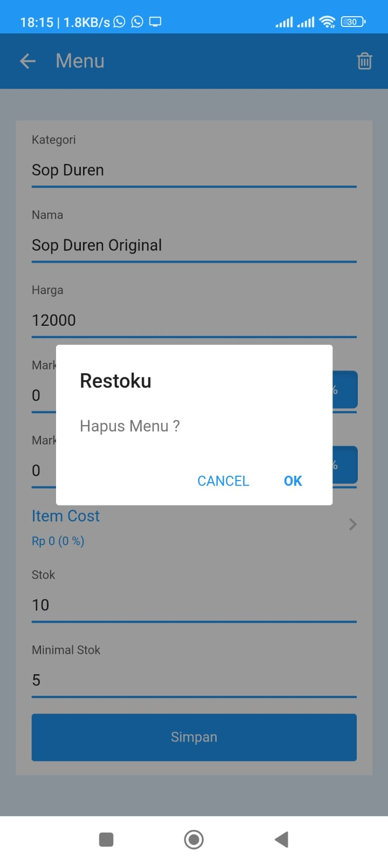

Kesimpulan :

Pada TS02 Capture Form dapat berhasil bila semua form telah terisi. Pada TS03 apabila E-mail dan Password benar dan klik tombol login maka login akan berhasil. Kemudian pada TS05 untuk insert menu dapat dilakukan apabila semua form kecuali form Markup Gofoof dan Markup Grabfood telah terisi. Lalu pada TS06 untuk dapat mendelete menu maka dilakukan langkah-langkah klik menu makanan lalu klik delete, kemudian klik OK dan menu akan terhapus.